**QR CODE DETECTION AND DECODING FROM IMAGES**

Sravani vinukonda

Department of Computer Science and Engineering

Lovely Professional University

Jalandhar, India

[Sravanivinukonda.05@gmail.com](mailto:Sravanivinukonda.05@gmail.com)

**Abstract:**

QR i.e. “Quick Response” code is a 2D matrix code that is designed by keeping two points under consideration, i.e. it must store large amount of data as compared to 1D barcodes and it must be decoded at high speed using any handheld device like phones. QR code provides high data storage capacity, fast scanning, omnidirectional readability, and many other advantages including, error-correction (so that damaged code can also be read successfully) and different type of versions. Different varieties of QR code symbols like logo QR code, encrypted QR code, QR Code are also available so that user can choose among them according to their need. Now these days, a QR code is applied in different application streams related to marketing, security, academics etc. and gain popularity at a really high pace. Day by day more people are getting aware of this technology and use it accordingly. The popularity of QR code grows rapidly with the growth of smartphone users and thus the QR code is rapidly arriving at high levels of acceptance worldwide.

**Introduction:**

Compared to 1D barcodes, 2D barcodes obtains higher fault tolerance and the ability of error correction. QR Code is a type of two-dimensional code. Recently, it has been increasingly widely used around the filed of electronic card, e-commerce and social network services. More applications are listed in the literature [1, 3, 6, 8, 10, 12, 13]. Furthermore, it can be used to aid blind

people to access web based voice information systems and services. A QR code is a type of matrix bar code or two-dimensional code that can store data information and designed to be read by smartphones. QR stands for “Quick Response” indicating that the code contents should be decoded very quickly at high speed. The code consists of black modules arranged in a square pattern on a white background. The information encoded may be text, a URL or other data . The QR code was designed to allow its contents to be decoded at high speed. The popularity of QR codes is growing rapidly all around the world. Nowadays, mobile phones with built-in camera are widely used to recognize the QR Codes. QR Codes are created by the Toyota subsidiary Denso Wave in 1994, and was initially used for tracking inventory in vehicle parts manufacturing. The idea behind the development of the QR code is the limitation of the barcode information capacity (can only hold 20 alphanumeric characters). While they are developed for tracking parts in vehicle manufacturing, QR codes now are used in many other fields, from commercial tracking to entertainment, in-store product labeling, and in those applications that are aimed at smartphone users. Users may open URL; receive text after scanning QR codes. By using QR code generating sites or apps, users can generate and print their own QR codes for others to scan and use. The QR code system consists of a QR code encoder and decoder. The encoder is responsible for encoding data and generation of the QR Code, while the decoder decodes the data from the QR code.

**Methodology:**

1. **Detection of QR Code:**

In this section, some structural aspects of QR codes will be described and we review some work since they are the most related to ours. Additional, a novel method for object detection are proposed to improve the performance of QR Code Detection.

* **QR CODE:**

Figure 1 shows that QR code contains the information of the finder pattern (FIP), timing pattern (TP), alignment patterns(AP),error correction code words, version information and so on. This information may be an important feature of our detection of QR codes.

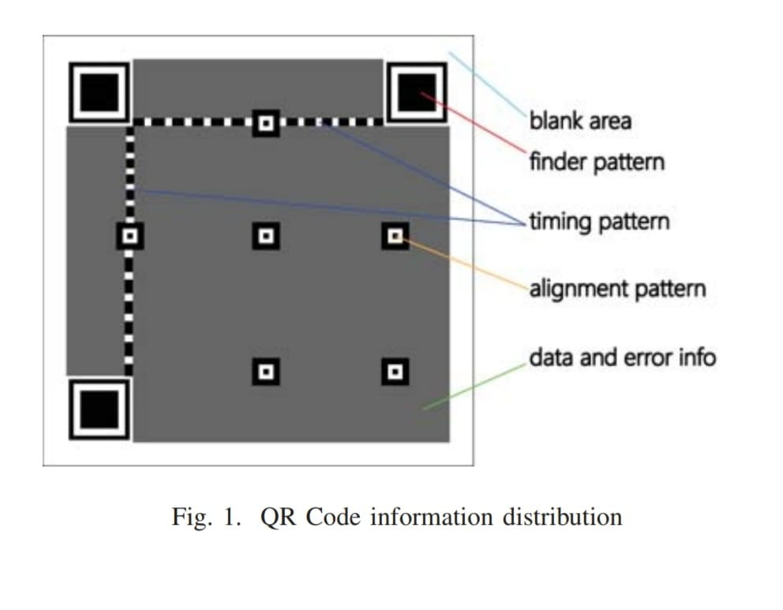

* **Component Aggregation Method:**

Component aggregation method [2] is divided into two phases. The FIP candidates are detected in the first stage, and in the second stage geometrical restrictions among detected components are verified to confirm the presence of a code. In the first stage, they proposed the use of Viola-Jones [14] rapid object detection framework for detecting FIPS. The details of the method refer to [2]. FIPs are typically the largest structures within a code and have a fixed shape. And Viola-Jones approach has the characteristics of fast speed and invariable to scale and illumination variations. Each FIP candidate from stage one is represented as a triple (T, x, y), where T is the size of the square region, x and y denote the coordinates of the center of that square. According to observation, the criteria should allow some tolerance to accommodate imprecision due to these conditions. Below we simply list the constraints, the details of the method refer to .

1. Size criterion: Two FIP candidates (T1, x1, y1) and (T2, x2, y2), Let T = max{T1, T2} and t = min{T1, T2}. The size criterion can be expressed by using the following expression: T − t < ξT (1) Where ξ means that maximum allowed size difference is at most ξ.
2. Distance criterion: Let T = max{T1, T2}, the distance criterion is defined as follows: 1.6T <= dist((x1, y1),(x2, y2)) <= 19√ 2 (2) 3) Orientation criterion: Let F1 = (T1, x1, y1) and F2 = (T2, x2, y2), Let |F1F2| denote the line segment length that links (x1, y1) and (x2, y2), F1F2 and F1F3 be two line segments with common extremity (x1, y1), θ be the angle between them, P = min{|F1F2|,|F1F3|} max{|F1F2|,|F1F3|} . {F1F2, F1F3} satisfies the orientation criterion as follows:

a) : θ = 90◦ and P = 1(i.e., |F1F2| = |F1F3|) or

b) : θ = 45◦ and P = √2 2

A small variation in the angle should be allowed. These can be parameterized by one single parameter d, so the orientation condition as:

c) : |90◦ − θ| <= d and 1 − cos(45◦−d)−cos(45◦+d) cos(45◦) <= P <= 1 or

d) : |45◦ − θ| <= d and cos(45◦ + d) <= P <= cos(45◦ − d)

Ideally, the component aggregation method for detecting QR code is very effective. However, the shortcoming in above researches can be summarized as following: (1) It ignores image pre-processing, resulting in low efficiency for blurred image detection. (2) It is a high demand for training set, training set directly affect the detection rate.

1. **Decoding QR Code:**

Decoding data from the QR code is the reverse of the encoding procedure. Figure 6 shows an overview of the decoding process .

• Recognizing Modules: Recognize dark and light modules as an array of “0” and “1” bits by locating and getting an image of the symbol.

• Extract Format Information: Decode the format information and release the masking pattern and apply error correction on the format information modules as necessary. Also obtain a mask pattern reference.

• Determine Version Information: If version information is applicable then decode it from the version information area and then determine the version of the QR code symbol.

• Release Masking: In order to release the masking, XOR the encoding region bit pattern with the Mask

Pattern whose reference has been extracted from the format information.

• Restore Data and Error Correction Codewords: Restore the data and error correction codewords of the message by reading the symbol characters (according to the placement rules for the model).

• Error Detection and Correction: By utilizing the error correction codewords, identify errors and if any error is detected, correct it.

• Decode Data Codewords: Divide the data codewords into segments according to the Mode Indicators and Character Count Indicators. And finally, decode the data characters according to the mode(s) in use and output the decoded text as result.

**Area of Application:**

Although the QR Code was originally designed to track automotive components but, now these days it is rapidly used in many other areas where traditional barcodes are used, such as Manufacturing, Retailing, Healthcare, and Transportation . Also, QR code found useful in some novel application Fig.8 Concept of Encrypted QR Code 43 fields including mobile marketing, online advertising, electronic ticket/coupon, electronic payment, identification, academics, information security, OMR sheet tampering detection etc. Mobile marketing gains popularity and has recently witnessed rapid growth, where the QR Code increasingly appears in print and online advertising, as well as on signs, hoardings, posters, and other particulars.

By scanning a QR Code with a smartphone, consumers can be connected to a relevant Web page or receive targeted marketing messages such as a special offer, discount coupon, product or store information, etc.

**Conclusion:**

In this paper, we studied QR code technology, its benefits, application areas, and its impact on marketing and technological world. Initially, QR code are developed and use for inventory tracking stuff but, now these days, they found applications in many new areas like marketing, advertising, secure payment systems, education industries, etc. Adoption of the QR codes grows rapidly during past years and number of users increases exponentially, due to its features like high data storage capacity, fast scanning, error-correction, direct marking and ease of use.

**References:**

* Dong-Hee Shin, Jaemin Jung, Byeng-Hee Chang “The psychology behind QR Codes: User experience perspective” ,Science Direct, Computers in Human Behavior 28 (2012) pp 1417-1426.
* Phaisarn Sutheebanjard, Wichian Premchaiswadi, “QR Code Generator”, IEEE 2010 8th International Conference on ICT and Knowledge Engineering (24-25 Nov. 2010) pp 89-92.
* ISO/IEC 18004:2000. “Information technology-Automatic identification and data capture techniques- Bar Code symbology- QR Code ”, 2000.
* Y. Yan, H.W. Liu, “Research and Application of Encoding and Decoding Tech. of QR Code”, University of Science and Tech, Beijing,
* T. Sriram, V.K. Rao, “Application of barcode technology in automated storage & retrieval systems”, Industrial Electronics Conference Proceedings. Taipei, 1996, pp. 5-10.
* R. Dorado, E. Torress, C. Rus, "Mobile learning: Using QR codes to develop teaching material", IEEE - Technologies Applied to Electronics Teaching (TAEE) 2016, Seville, Spain,22-24 June 2016.
* Sumit Tiwari, Sandeep Sahu, “A Novel Approach for the Detection of OMR Sheet Tampering Using Encrypted QR Code”, IEEE -International Conference on Computational Intelligence And Computing Research (2014), Coimbatore – India, 2014, pp. 604-608.
* H. S. Al-Khalifa. Utilizing QR code and mobile phones for blinds and visually impaired people. In Computers Helping People with Special Needs, International Conference, Iccha 2008, Linz, Austria, July 9-11, 2008. Proceedings, pages 1065–1069, 2008.
* L. F. Belussi and N. S. Hirata. Fast component-based QR code detection in arbitrarily acquired images. Journal of Mathematical Imaging and Vision, 45(3):277–292, 2013.
* U. B. Ceipidor, C. M. Medaglia, A. Perrone, M. D. Marsico, and G. D. Romano. A museum mobile game for children using QR-codes. In Interaction Design and Children, Proceedings of the International Conference on Interaction Design and Children, IDC 2009, Como, Italy, June, pages 282–283, 2009.
* Q. Chen, Y. Du, R. Lin, and Y. Tian. Fast QR code image process and detection. 2012.
* C. H. Chu, D. N. Yang, and M. S. Chen. Extracting barcodes from a camera-shaken image on camera phones. In IEEE International Conference on Multimedia and Expo, ICME 2007, July 2-5, 2007, Beijing, China, pages 2062–2065, 2007.
* J. Coughlan, R. Manduchi, and H. Shen. Cell phonebased wayfinding for the visually impaired. In st Int. Workshop on Mobile Vision, 2006.
* Y. Ebrahim, W. Abdelsalam, M. Ahmed, and S. C. Chau. Proposing a hybrid tag-camera-based identification and navigation aid for the visually impaired. In IEEE Consumer Communications and NETWORKING Conference, pages 172–177, 2005.